

**CYBER DEFENSE CIS098-6 BLOCK 2**

**FULL ATTACK DEMONSTRATION USING SNIPER AGAINST METASPLOITABLE 2**

**BY**

**FATOBA, OLUWAPELUMI BLESSING. 2333318.**

**Dec 24th, 2024.**

**TABLE OF CONTENTS**

1.0. WHAT IS SN1PER, SN1PER IN CYBER DEFENSE. 3

1.1. Attack Analysis In Cyber Defense: 3

1.2. Vulnerabilities: 3

1.3. Simulation of the Attacker’s Behaviour: 3

1.4. Early Security Risk Detection: 4

1.5. Upgrading Web Application Security: 4

2.0. METASPLOITABLE 2. METASPLOITABLE IN CYBER DEFENSE. 4

2.1. KEY ROLES IN CYBER DEFENSE 5

3.0. Exploiting Metasploitable 2 5

3.1. Features of Sn1per 20

4.0. Successful Completions of The Two Cisco Courses 24

4.1. Conclusion 25

4.2. References 25

LIST OF FIGURES

Figure 1: Metasploitable 2 Virtual Machine………………………7

Figure 2: Metasploitable 2 Network Settings…………………….7

Figure 3: Kali Linux Network Settings………………………………..8

Figure 4: Sniper installation………………………………………………8

Figure 5: Metasploitable 2 Login Page………………………………9

Figure 6: Metasploitable 2 Network Configuration…………..9

Figure 7: Discovering Networks………………………………………..10

Figure 8: Networks Discovered…………………………………………10

Figure 9: Run Sniper…………………………………………………………11

Figure 10: Sniper Running………………………………………………..11

Figure 11: Open Ports Discovered……………………………………12

Figure 12: Testing Open Ports………………………………………….12

Figure 13: Backdoor Discovered, Open Session………………..13

Figure 14: Exploiting Backdoor…………………………………………13

Figure 15: User Accounts………………………………………………….14

Figure 16: Logged In Users……………………………………………….14

Figure 17: Misconfigured Services…………………………………….15

Figure 18: Hashed Passwords……………………………………………15

Figure 19: Ran Nmap…………………………………………………………16

Figure 20: Potential Targets.……………………………………………..16

Figure 21: Exploitation Contiinues…………………………………….17

Figure 22: List of Users………………………………………………………17

Figure 23: More Testing By Sniper……………………………………..18

Figure 24: InjectX……………………………………………………………….18

Figure 25: Smuggler…………………………………………………………..19

Figure 26: Smuggler contination………………………………………..19

Figure 27: BruteX……………………………………………………………….20

Figure 28: BruteX testing……………………………………………………20

Figure 29: Sniper Done Operation Successful…………………….21

Figure 30: BruteX……………………………………………………………….22

Figure 31: -t…………………………………………………………………..…..22

Figure 32: Web Scan…………………………………………………………..23

Figure 33: Using (Webscan)………………………………………………..23

Figure 34: --status……………………………………………………………….24

Figure 35: Using (--status)…………………………………………………..24

Figure 36: Network Defense……………………………………………….25

Figure 37: Gradebook Network Defense……………………………..25

Figure 38: Cyber Threat Management…………………………………26

Figure 39: Gradebook Cyber Threat Management……………….26

# 1.0. WHAT IS SN1PER, SN1PER IN CYBER DEFENSE.

1N3 Sn1per(Sniper) is a very powerful and open source penetration testing tool that is used for exploitation, vulnerabilities and reconnaissance and giving detailed response. It combines various security tools and techniques to simplify the penetration testing process.

Although Sniper is associated as a tool with offensive security and used for penetration testing, it also provides huge benefits for cyber defense roles as well. By employing Sniper as part of a defense strategy, organizations are able to identify vulnerabilities, assess risks, and simulate an attacker's methodology. Here are ways sniper can be used in Cyber Defense;

**KEY ROLES IN CYBER DEFENSE**

## 1.1. Attack Analysis In Cyber Defense:

* Sniper identifies outdated softwares that leads to unintended exposures and misconfigured servers.
* It maps attack surfaces to understand the attackers potential points of entry.
* Sniper also corrects potential exploits by patching, closing unused open services, and changing firewall rules if necessary.

## 1.2. Vulnerabilities:

* Sniper uses tools like nmap, OpenVAS and nikto to identify vulnerabilities in a system and its applications.
* It cross checks vulnerabilities found with threat intelligence to understand how they can be exploited.
* Detailed reports are generated for vulnerabilities.

## 1.3. Simulation of the Attacker’s Behaviour:

* Sniper automates vulnerability scanning techniques used by real world attackers.
* It identifies the gaps in detection and monitoring.
* It tests the intrusion detection/prevention system effectiveness.

## 1.4. Early Security Risk Detection:

* Find recently opened services or ports that shouldn't be available.
* Determine which devices are unapproved or rogue and are joining the network.
* Keep an eye out for any possible manipulation or misconfigurations of DNS records or SSL certificates.

## 1.5. Upgrading Web Application Security:

* Assess how resistant web apps are to automated attacks....
* During development, make sure secure coding principles are followed.....
* Examine login procedures for multi-factor authentication and brute-force defense.

In summary, as a vital part of cyber defense, the Sn1per tool provides a thorough approach to detecting and reducing security threats. By carefully examining systems and networks to find attack vectors and comprehend possible exploitation techniques, it aids in attack analysis. By detecting vulnerabilities such as out-of-date software, weak credentials, and misconfigurations, Sn1per helps defenders fix them before attackers take advantage of them. It gives insight into how attackers could approach a target by simulating attacker behavior and reproducing real-world tactics, allowing for the development of strong defensive methods. Security teams can quickly address new dangers, such unauthorized devices or exposed services, thanks to its early security risk detection capabilities. Sn1per reduces the danger of exploitation by allowing defenders to prioritize patch management, harden their infrastructure, and enhance intrusion detection and response systems by imitating attacker behavior.

# 2.0. METASPLOITABLE 2. METASPLOITABLE IN CYBER DEFENSE.

A vital tool for developing, testing, and enhancing cyber defensive tactics, Metasploitable 2 is an intentionally compromised virtual machine created to mimic real-world vulnerabilities. It is frequently used in controlled settings to teach security experts how to find and fix vulnerabilities before they are applied against real-world systems. Metasploitable 2 enables defenders to practice vulnerability scanning, pen testing, and response to incidents without endangering live environments by simulating typical vulnerabilities found in out-of-date software, misconfigured services, and insecure web applications. It is perfect for testing security solutions and confirming it's effectiveness against established attack techniques because it is compatible with programs like Metasploit, Nmap, and Wireshark.

Metasploitable 2 provides a secure environment for developing detection and mitigation strategies in cyber defense. Blue teams can use it to test defenses like intrusion detection systems (IDS), simulate attacks, and evaluate how well logging and monitoring systems work. Teams are also trained in vulnerability assessment and management using Metasploitable 2, which enables them to prioritize patching efforts, identify threats, and ensure strict compliance to security policies. Its function in generating realistic attack scenarios assures that defenders are ready for evolving threats and improves their abilities to effectively protect organizational assets.

## 2.1. KEY ROLES IN CYBER DEFENSE

* Vulnerability Identification: Provides defenders with a secure environment in which to practice finding and analyzing vulnerabilities.
* Tool testing: This enables the evaluation and evaluation of defensive tools such as vulnerability scanners, firewalls, and intrusion detection systems (IDS).
* incident response training: Teams learn how to effectively respond to cyber threats by using incident response training, which offers realistic attack scenarios.
* Skill Development: Helps security professionals gain practical experience to improve their knowledge of cyber defense techniques.

# 3.0. Exploiting Metasploitable 2

First the installation of metasploitable 2, metasplotable 2 can be downloaded from Rapid7.com. Rapid7 is a cybersecurity company that offers various services and softwares alike. Using this link “<https://www.rapid7.com/products/metasploit/metasploitable/> “ (Rapid7, 2024) you wil be able download it straight from their site. Extract the file then head over to your virtual machine for installation, everything I will be doing will be performed on **Oracle Virtual Box.** Below is an image of my virtual box with the metasploitable 2 configurations name, operating system, base memory (although my base memory is high, it can wok with less memory, I think 1500mb should suffix), processesors and so on.

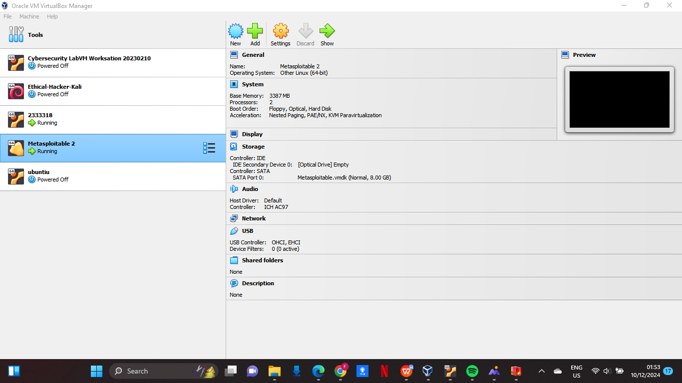

Figure 1: Metasploitable 2 Virtual Machine

Next we set the network adapter as a host only adapter on both kali linux and the newly created metasploitable 2. This is to ensure that the ip addresses on both VMs are not identical so we can single out metasploitable 2 and exploit it.

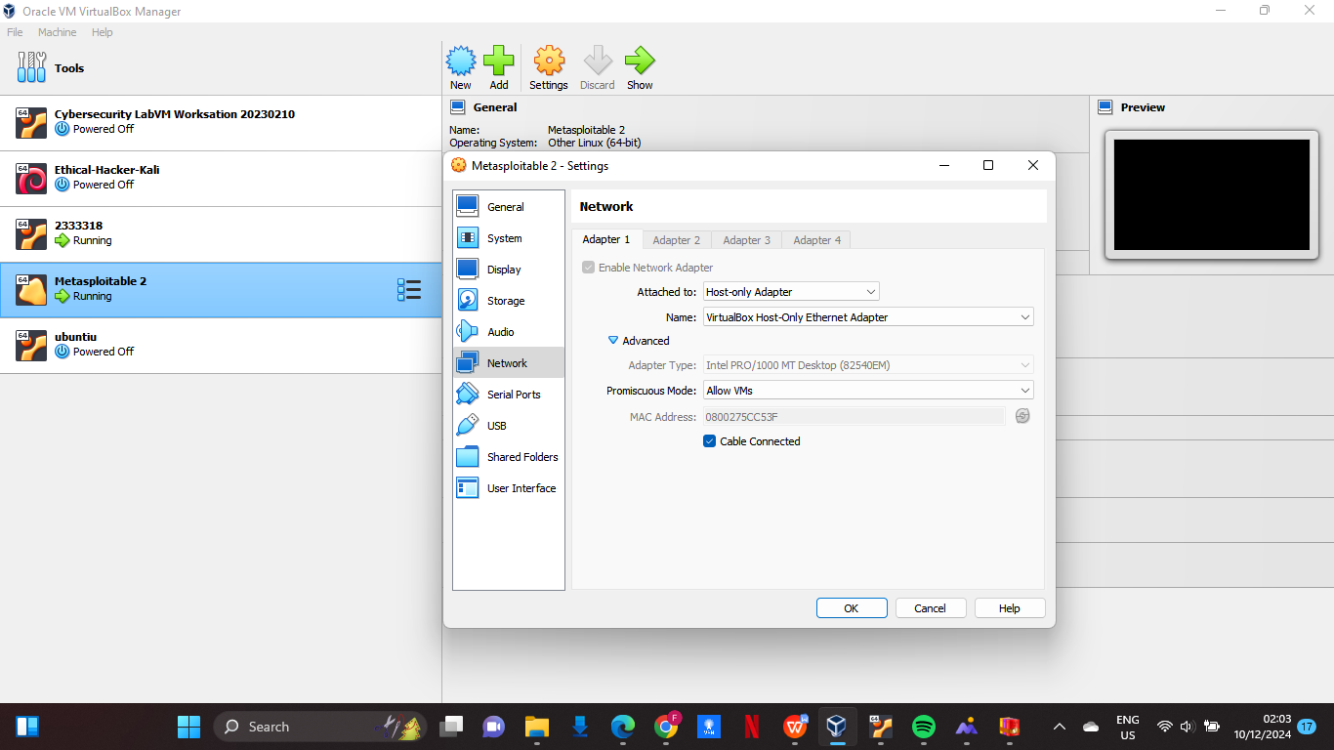

Figure 2: Metasploitable 2 Network Settings

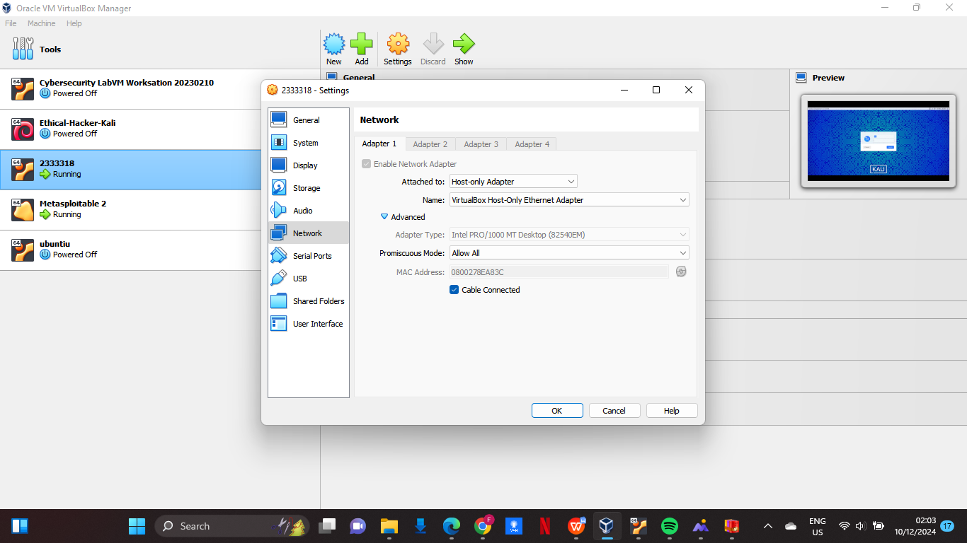

Figure 3: Kali Linux Network Settings

As we can see on both images above the network adapters are the same, this is to ensure that they do not posses the same IP address.

Now we go to kali linux and install sniper from my root terminal using the command cd sniper, then bash install.sh.

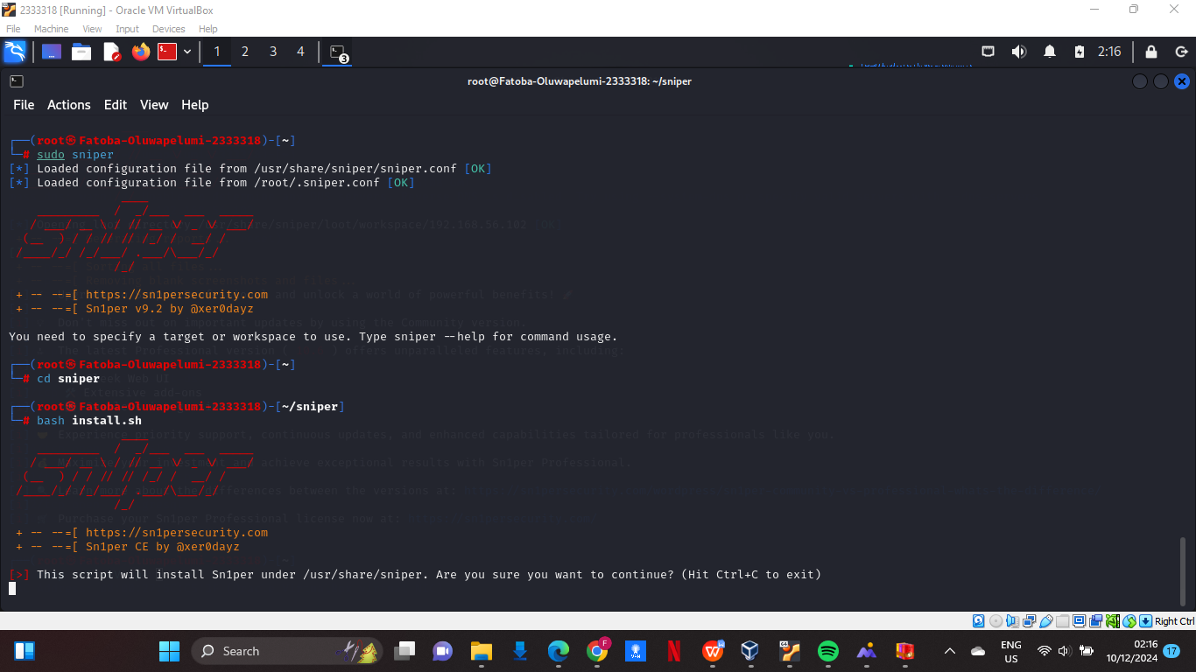

Figure 4: Sniper installation

Once the installation has been completed then we can move on to exploit it. First thing is that we need the ip address of metasploitable 2, this can be done in two ways first we can just login on metasploitable 2 with msfadmin/msfadmin for the username and password.

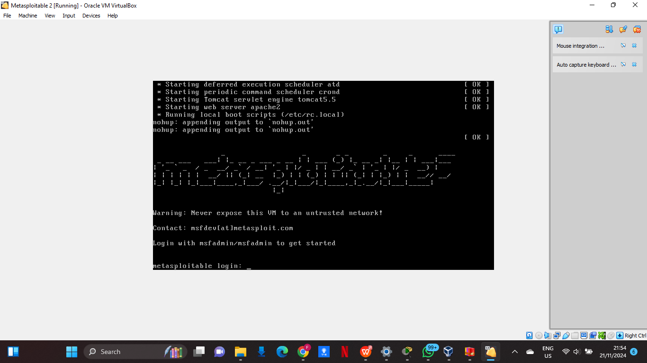

Figure 5: Metasploitable 2 Login Page

Then we use the ifconfig command to get details on the eth0 configuration and inet address.

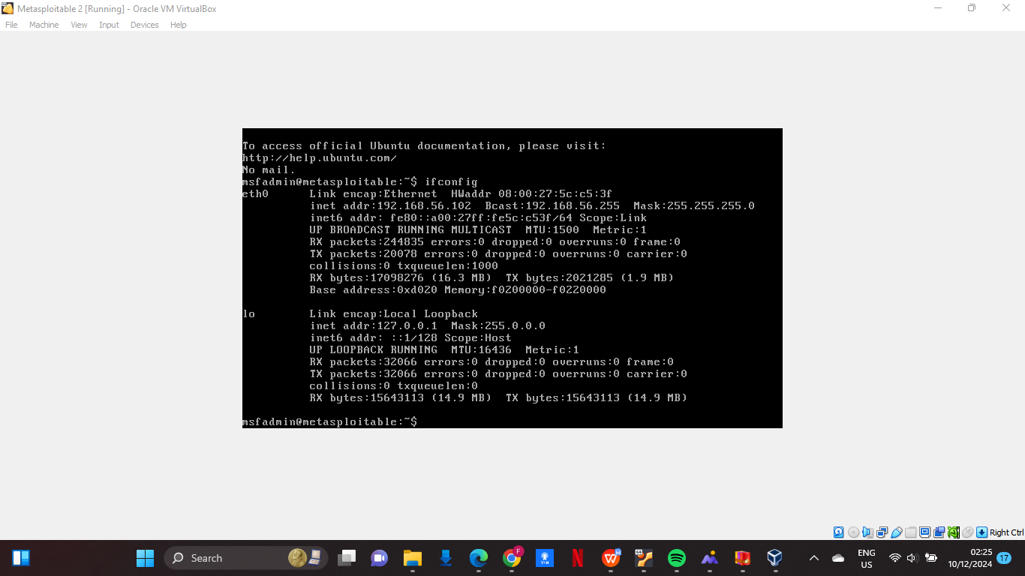

Figure 6: Metasploitable 2 Network Configuration

That is one way, but we do not want to do it this way. So lets logout on our metasploitable 2 vm and leave it running, then we will logon to our linux vm and ping the vm from the terminal. Using the command ‘sudo netdiscover’ on kali, it will show me all the available ip and mac addresses that are on my system;

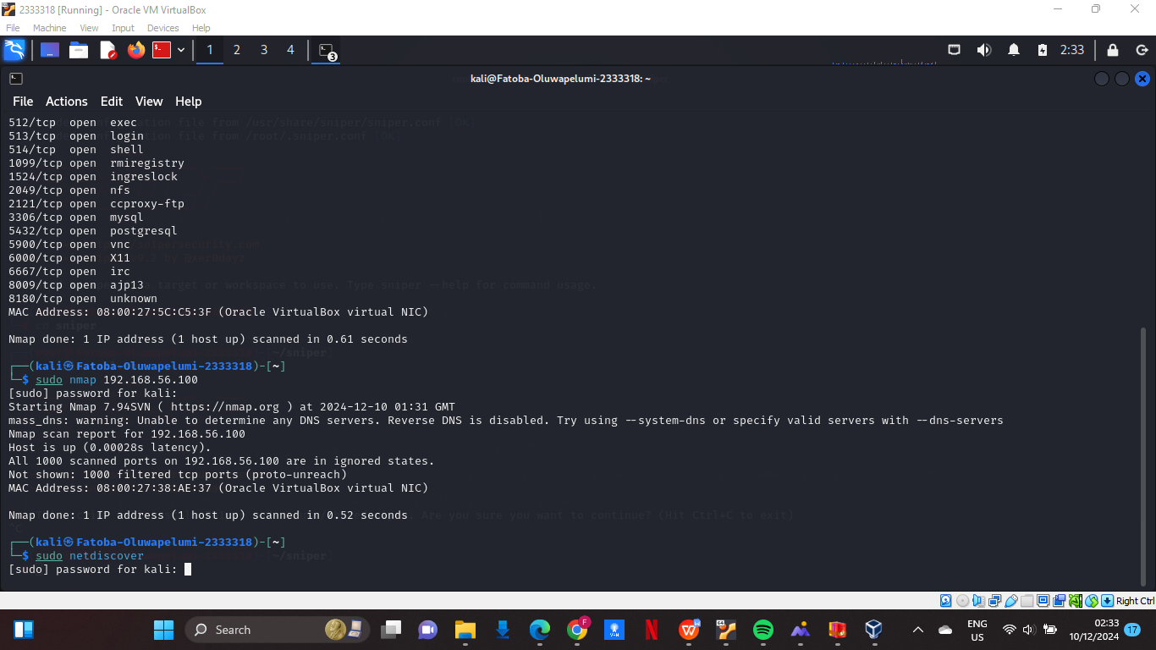

Figure 7: Discovering Networks

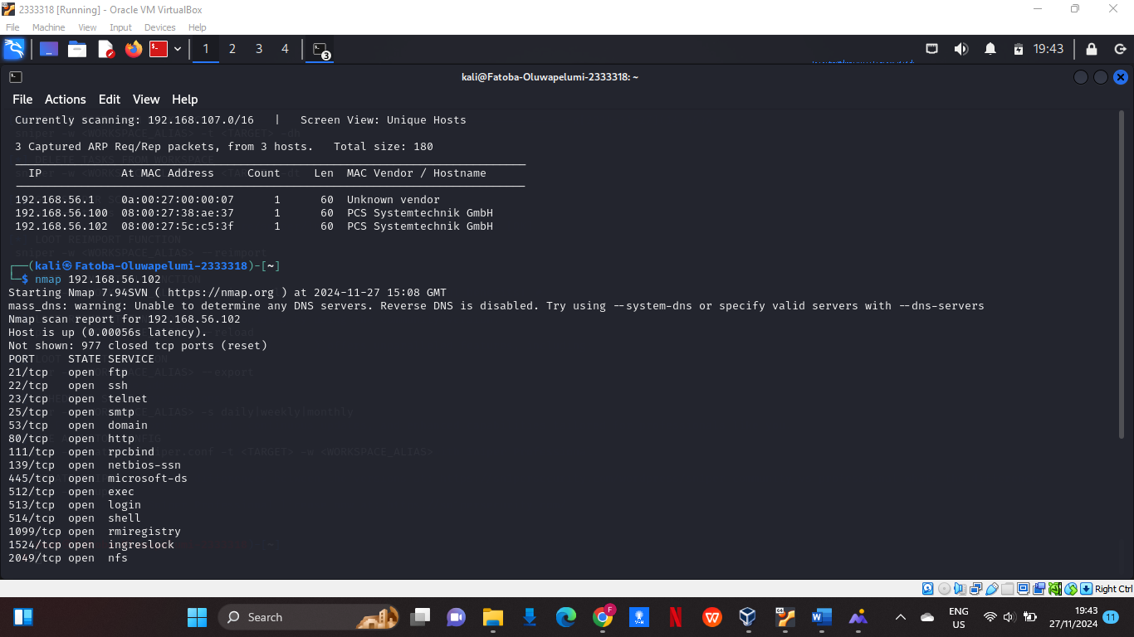

Figure 8: Networks Discovered

The available IP’s and mac addresses are shown, then we nmap was ran for the second IP address as the first one is for the kali VM. Nmap shows me all the open tcp ports that are available on the metasploit VM.

As I can now view all the open ports, I will run sniper on my root terminal to start the exploit on the vm.

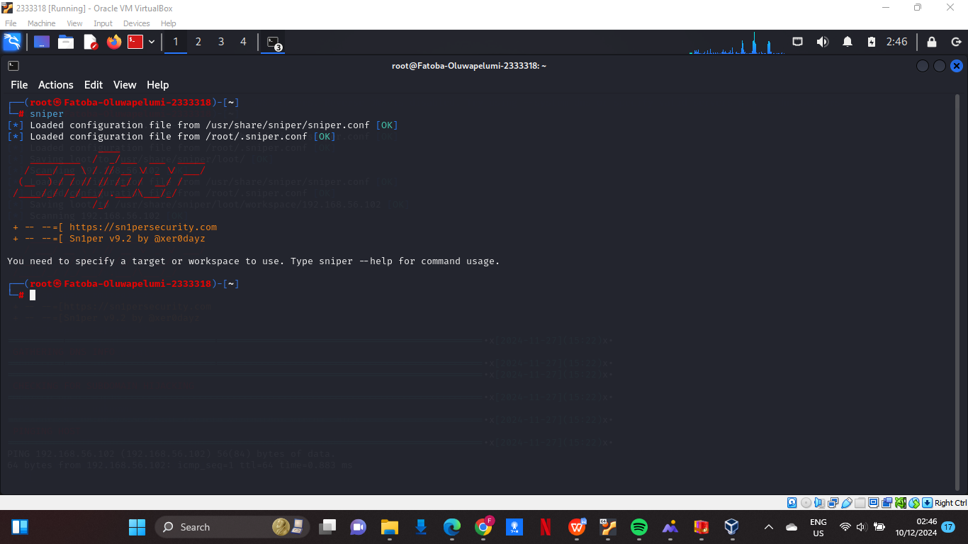

Figure 9: Run Sniper

Now sniper is up and ready for use. Now we want to target the ip address for metasploitable 2, maybe I will bruteforce using command ‘-b’ (to bruteforce on sniper means to make automated password-cracking attempts against particular login services or protocols).

Now the pen testing has started so sniper is going to identify all the open ports available and it is going to scan through them;

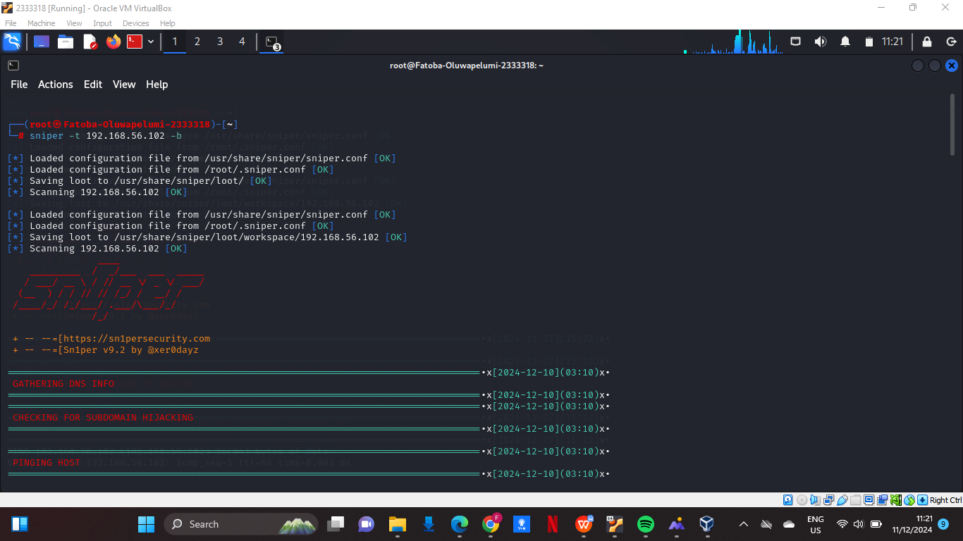

Figure 10: Sniper Running

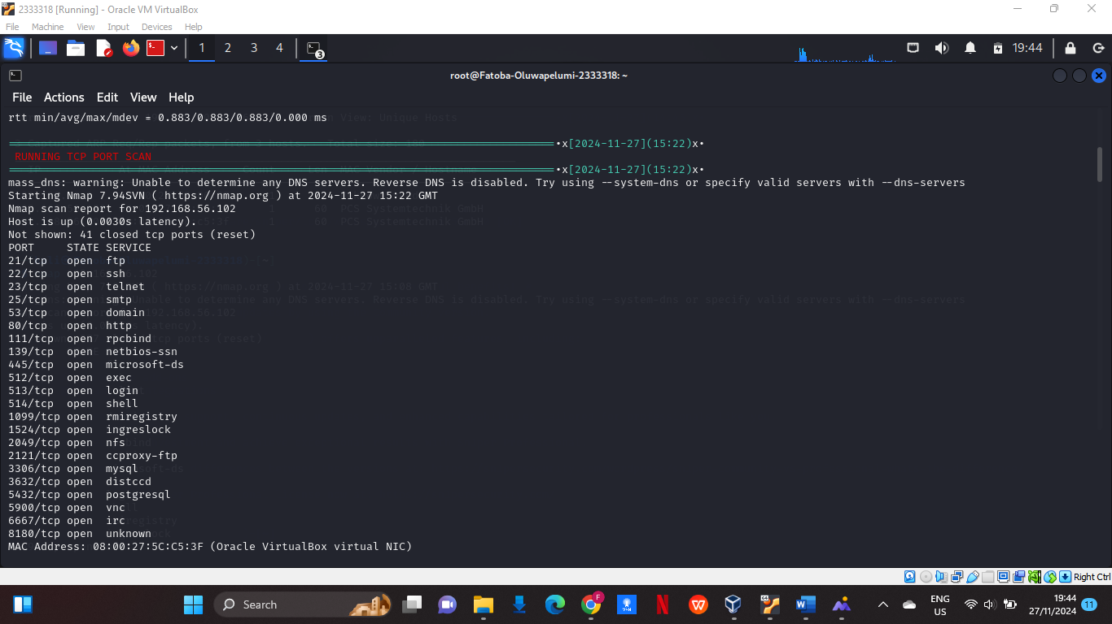

Figure 11: Open Ports Discovered

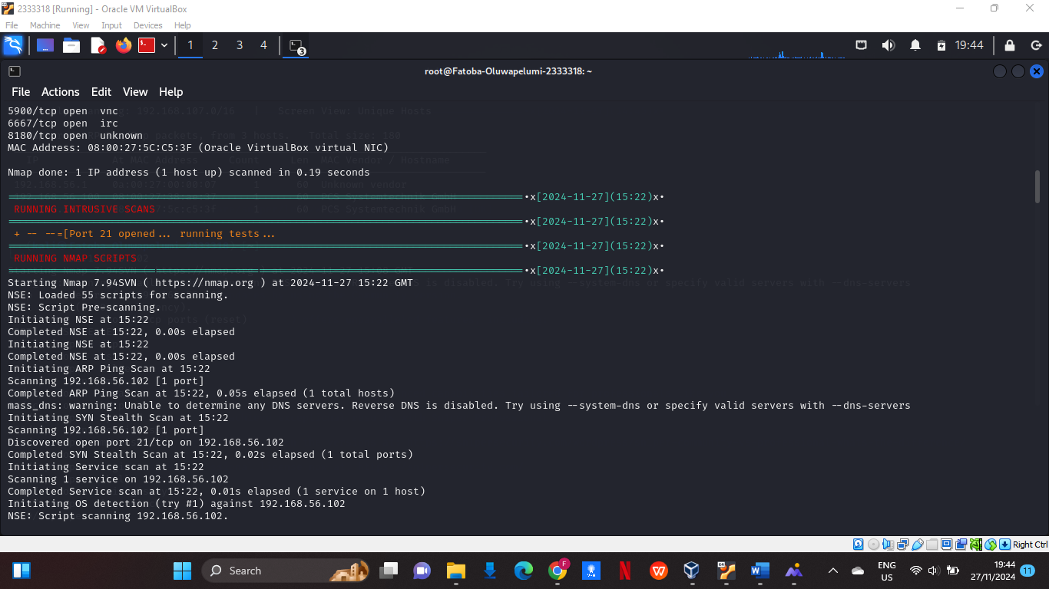

Figure 12: Testing Open Ports

Then the process goes on for about a minute or so the speed could vary depending on the system or number of processors allocated to kali linux. Then a session will be created as sniper will find a backdoor on metaspolit which can be further exploited;

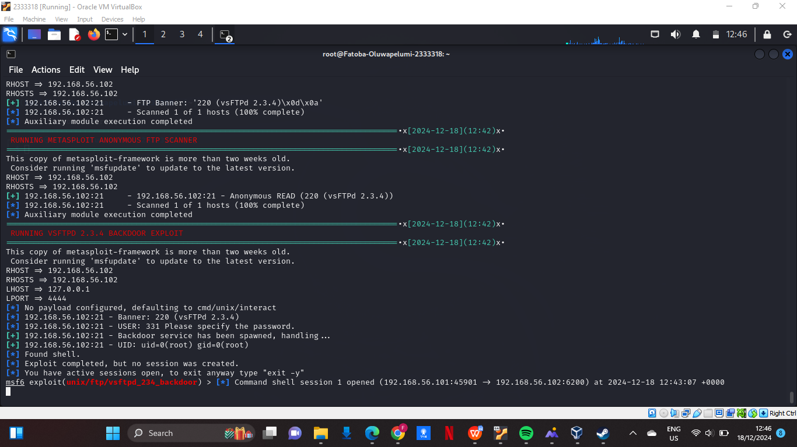

Figure 13: Backdoor Discovered, Open Session

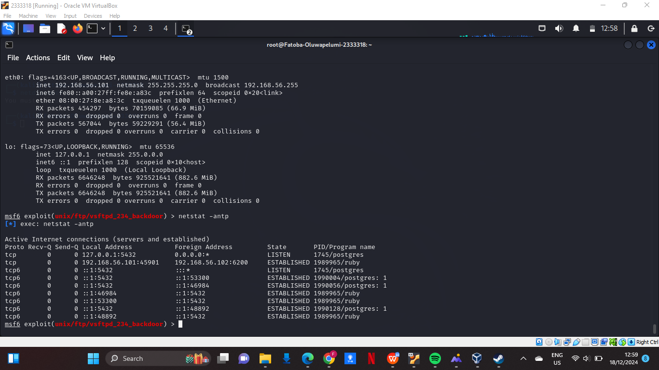

Figure 14: Exploiting Backdoor

First I will be looking at the network configuration then I will continue to exploit the system further for more info, login credentials, documents and so on. The first command used here is the “ifconfig” command that shows the IP address, mac address the network details. Then we take a look at the active connections using the “netstat -antp” command.

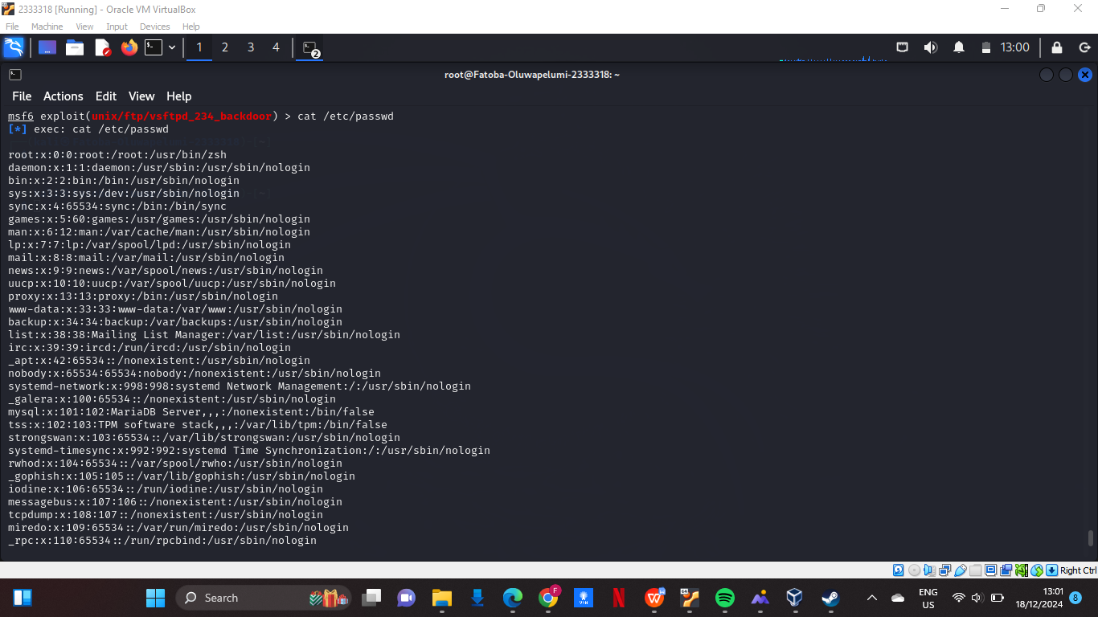

Figure 15: User Accounts

Then we take a look at the user accounts on the system using the “cat /etc/passwd” command.

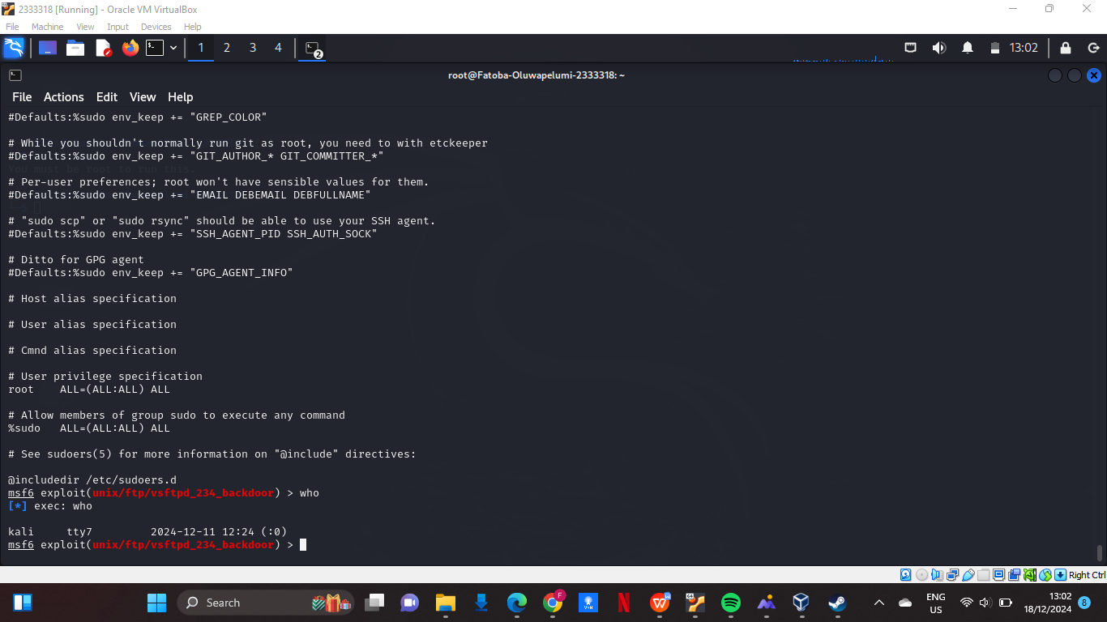

Figure 16: Logged In Users

To list the users currently logged in I used the “who” command.

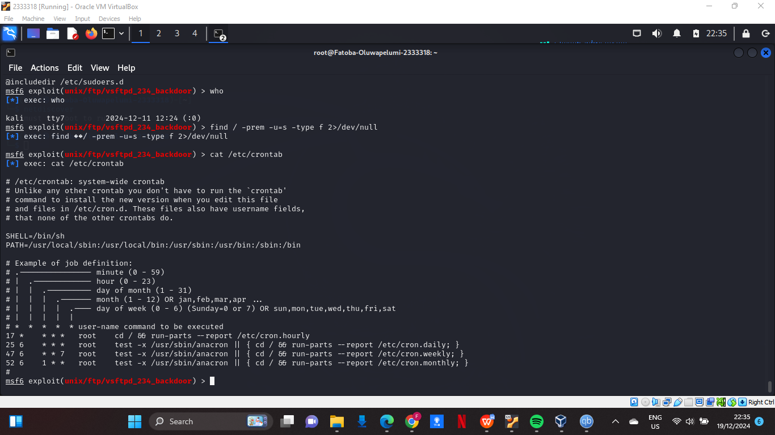

Figure 17: Misconfigured Services

I wanted to check for misconfigured services and I used the “cat /etc/crontab”.

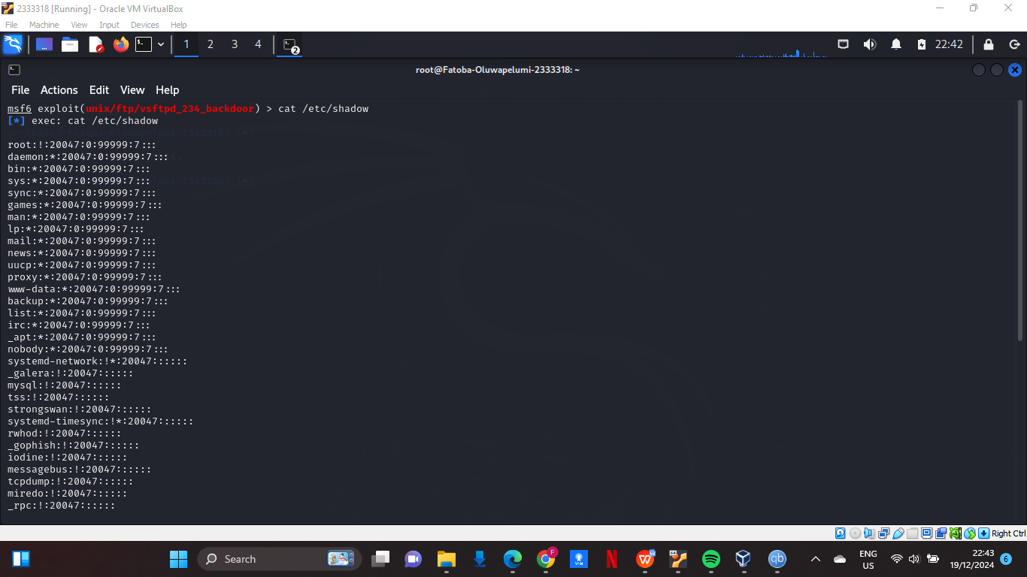

Figure 18: Hashed Passwords

Using “cat /etc/shadow” I am able to get a dump of hashed passwords, to further exploit this password tools like Jack The Ripper or Hash Cat can be used along with “/etc/passwd” command to get the list of users, then using these tools you can brute force the user accounts to get more information.

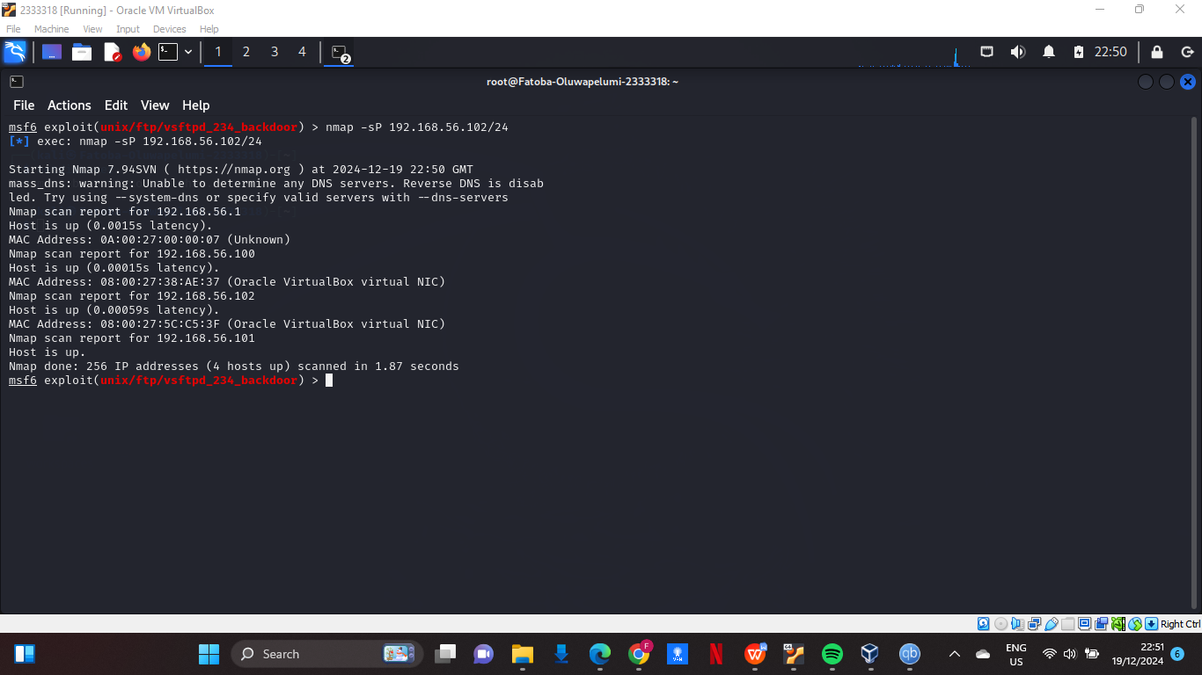

Figure 19: Ran Nmap

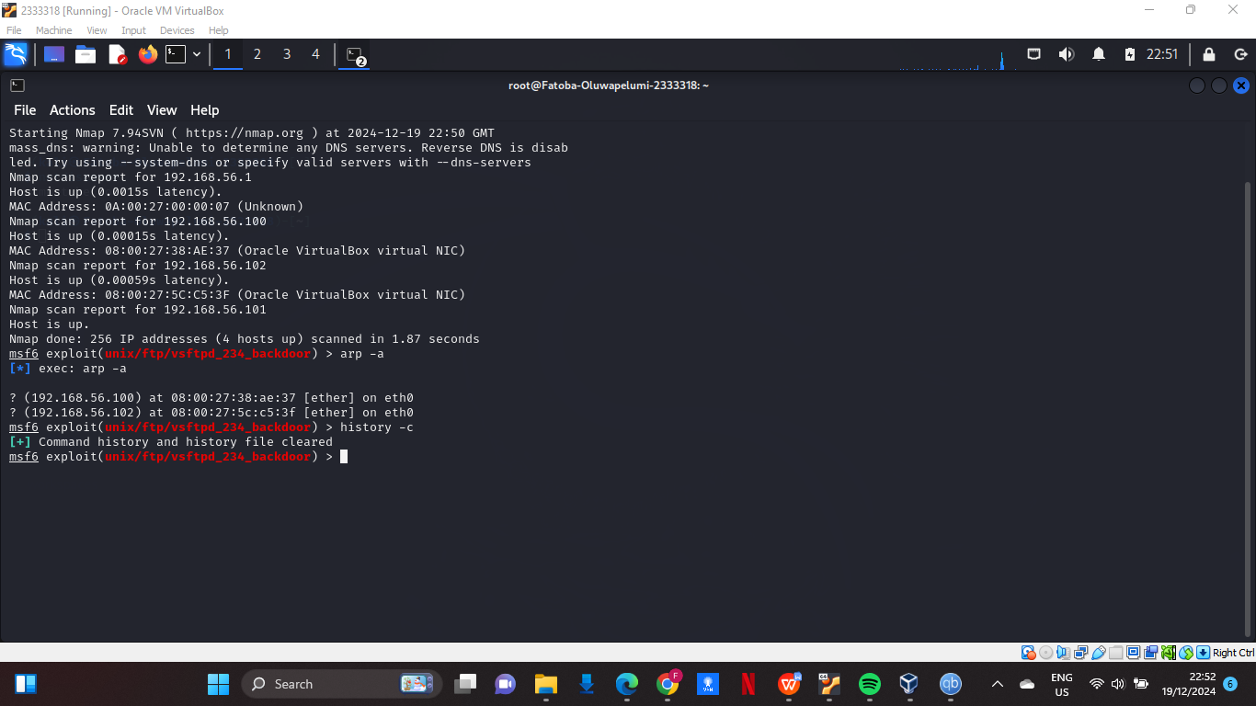

Figure 20: Potential Targets

The next things I did in this backdoor session are as follows, I ran a nmap command to scan the network for more potential targets, then I used the arp command to check connected systems in the arp cache which are the kali and metasploitable as shown, then I ran history -c to clear bash history to clear my traces.

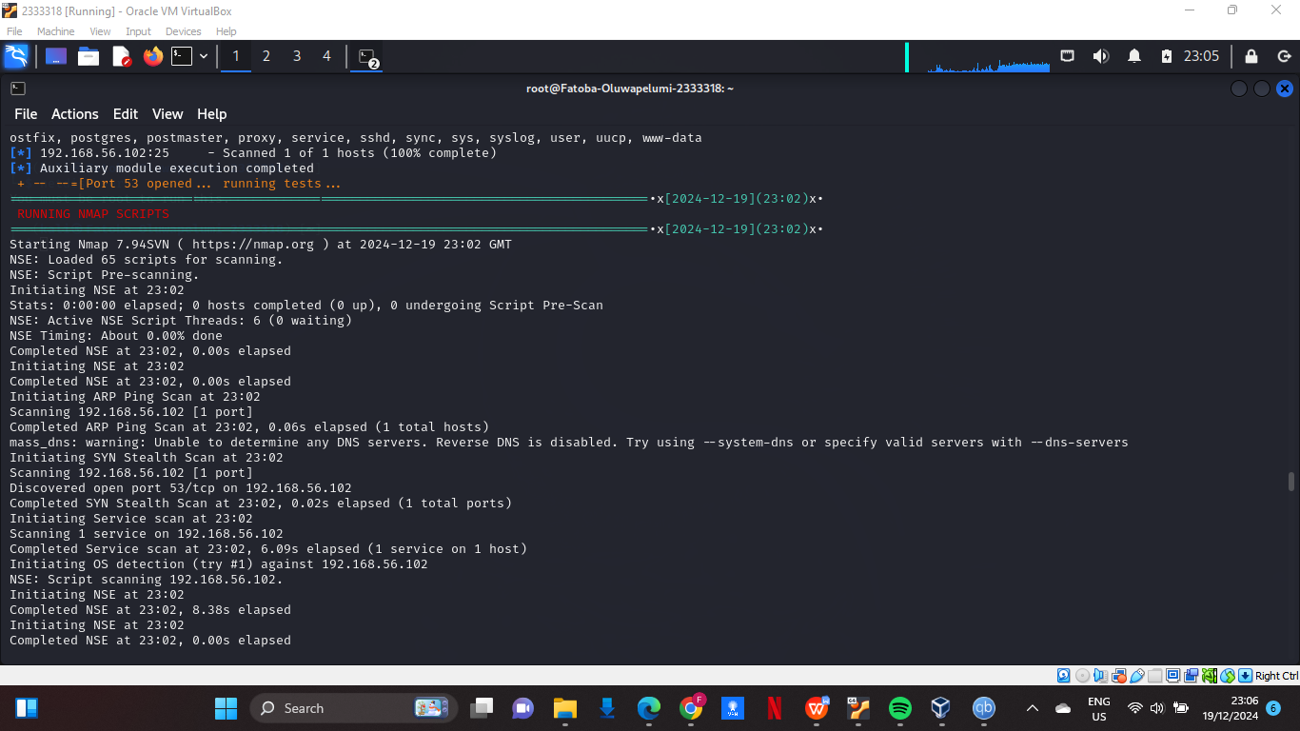

Figure 21: Exploitation Contiinues

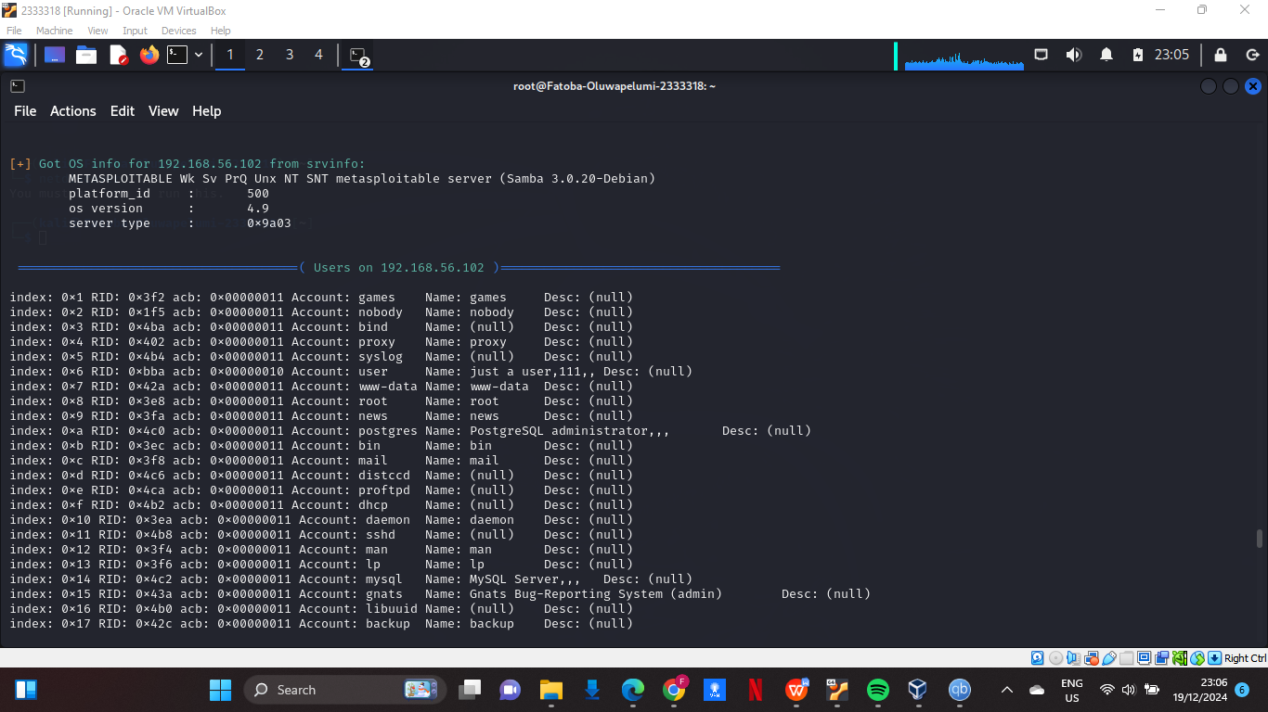

Figure 22: List of Users

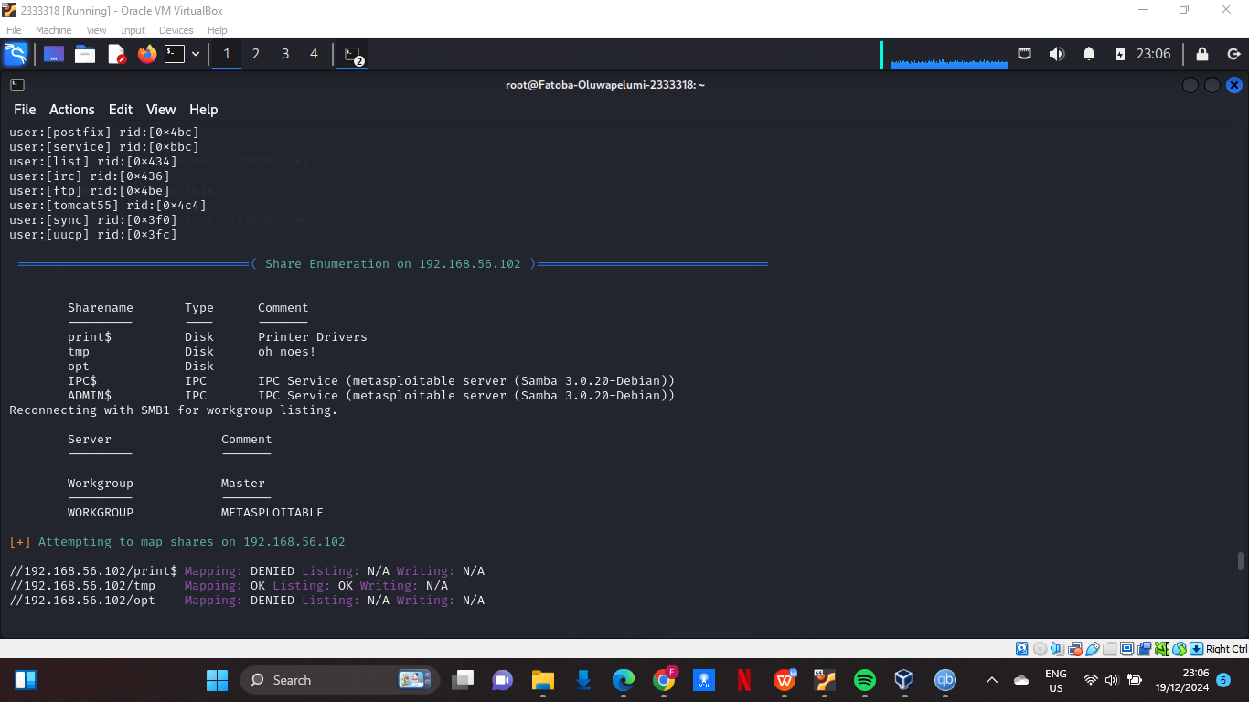

Figure 23: More Testing By Sniper

After I exited the back door using the command “exit -y” the program continued to run as it further showed me the users, shared enumeration then other programs ran to further test the system;

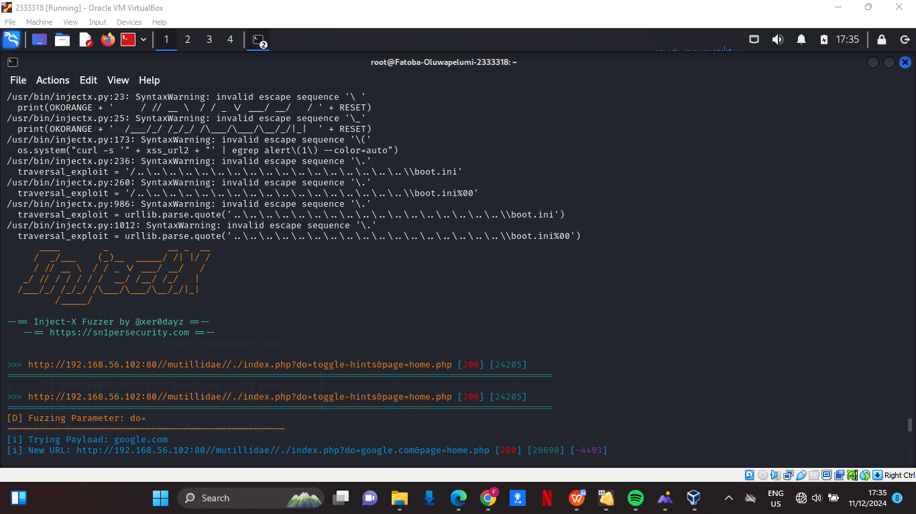

Figure 24: InjectX

As sinper contains multiple pen testing tools one of it’s key features sniper continues to make use of them to archive it’s goal. InjectX operates by scanning for vulnerabilities by replacing the parameters of HTTP request to see the response, then;

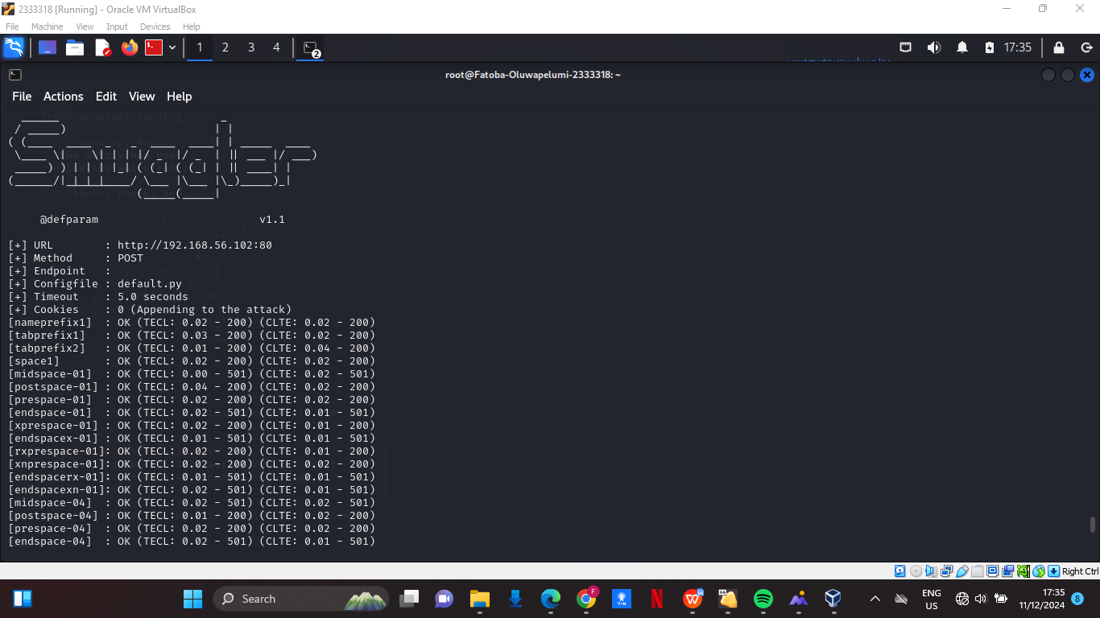

Figure 25: Smuggler

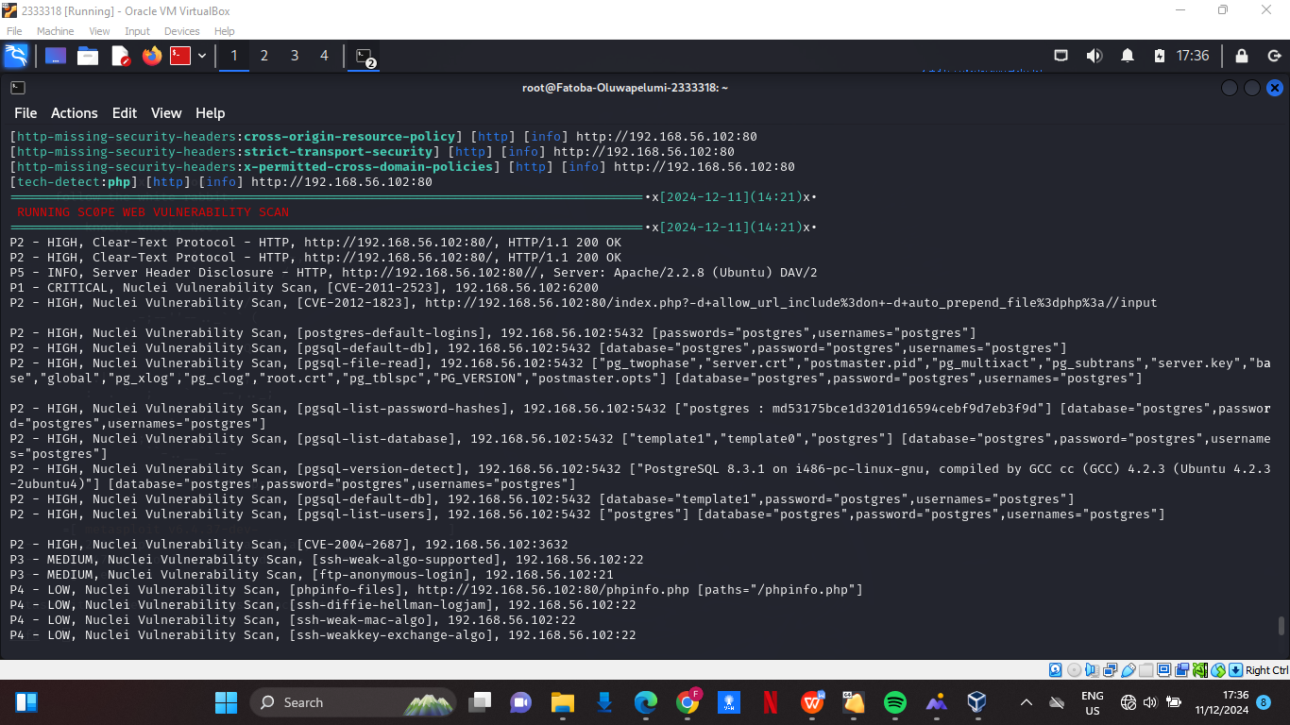

Figure 26: Smuggler contination

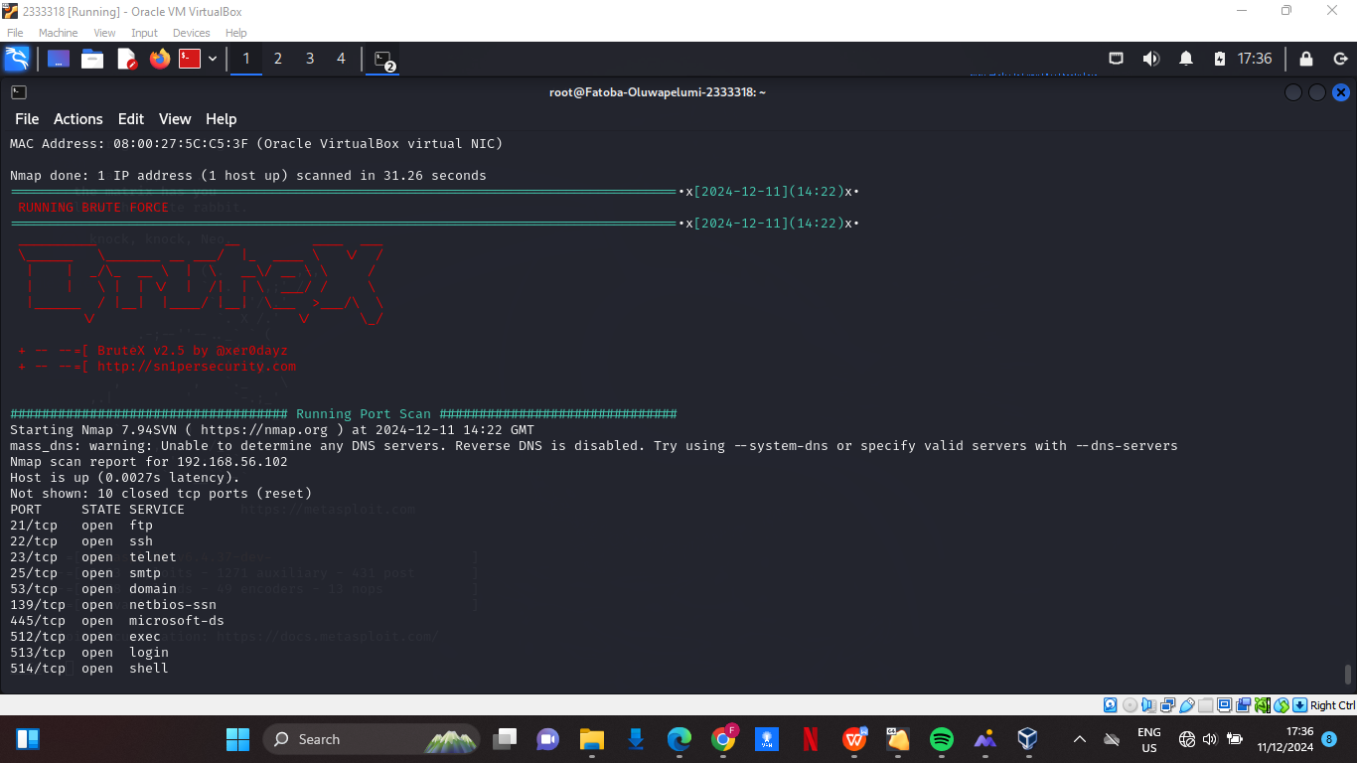

Figure 27: BruteX

The command at the very beginning “-b” ran;

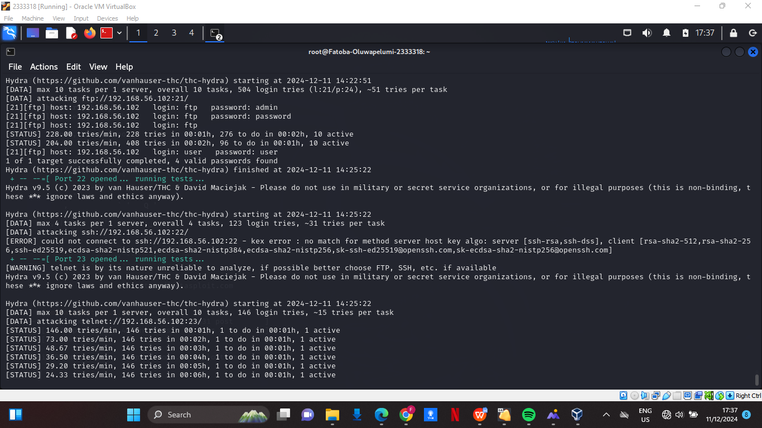

Figure 28: BruteX testing

Then it started trying different password on the user accounts some were successful in 4 to 10 tries others took a lot more, after all this the program stopped as the program was successful;

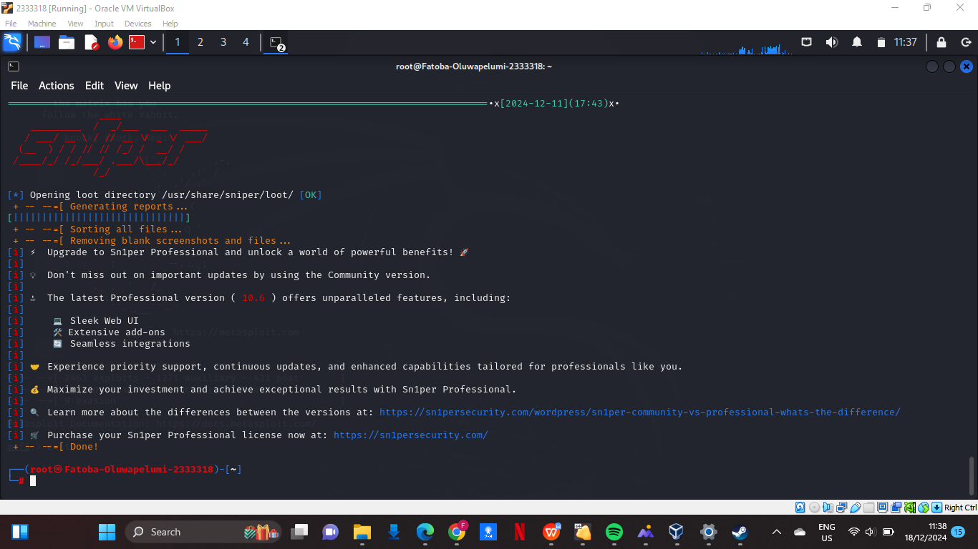

Figure 29: Sniper Done Operation Successful

## 3.1. Features of Sn1per

Some of the features of sniper have been used already during this explaination, as sniper has the ability or rather it uses other softwares for vunerability testing and pen testing, we don’t get to use them manually as sniper automates the processes to give a favourable outcome. Features like bruteforce, injectx has been used already, status “--status” as a feature it filters and displays results based on http return codes, it focuses on specific successful requests or errors to help identify vulnerabilities (this can be helpful when using injectx or smuggler). I also made use of web scan. Web scan is used for comprehensive inspection of a target web application. It can find vulnerabilities like SQL Injections, XSS, and Command Injections. It automates payload testing, vulnerability detection, and parameter checking across the inputs and endpoints of the web applications.



FIGURE 30: BRUTEX

This operates by trying different password on the user accounts some were successful in 4 to 10 tries others took a lot more, after all this the program stopped as the program was successful.

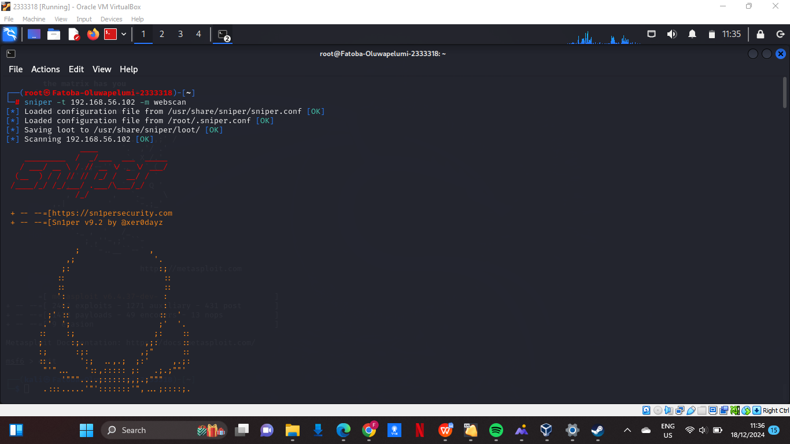

FIGURE 31: -t

This operates by targeting a specific IP address and running the scans against it, basically the operation start of sniper.

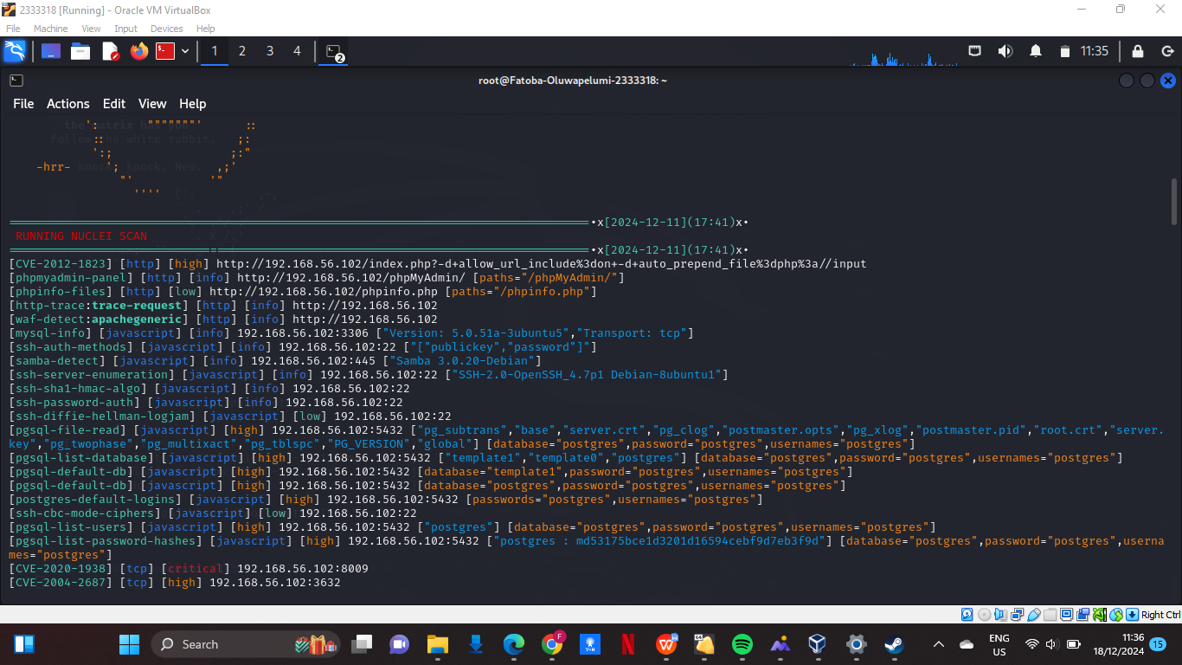

Figure 32: Web Scan

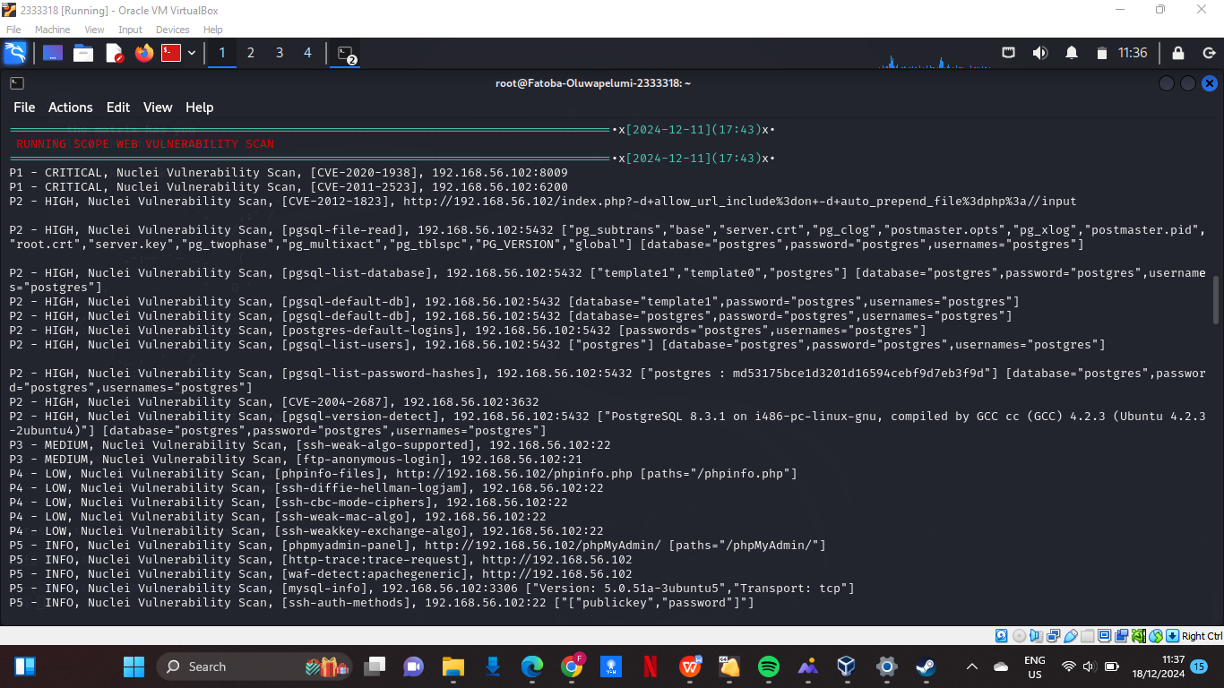

Figure 33: Using (Webscan)

Web scan is used for comprehensive inspection of a target web application. It can find vulnerabilities like SQL Injections, XSS, and Command Injections.

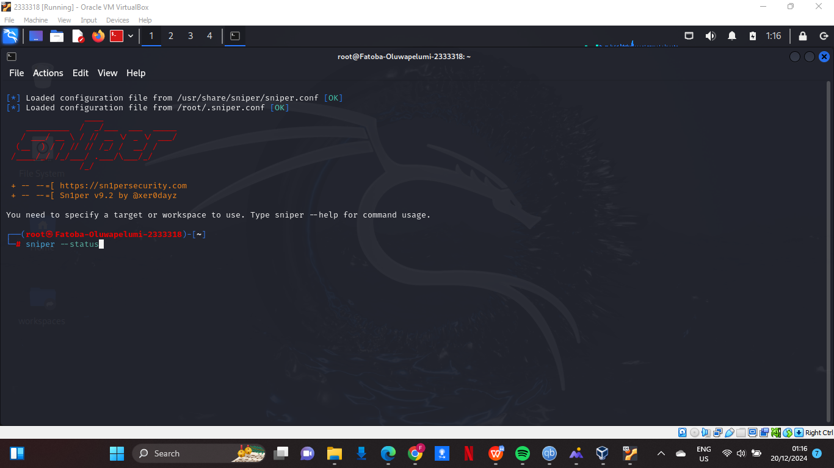

Figure 34: --status

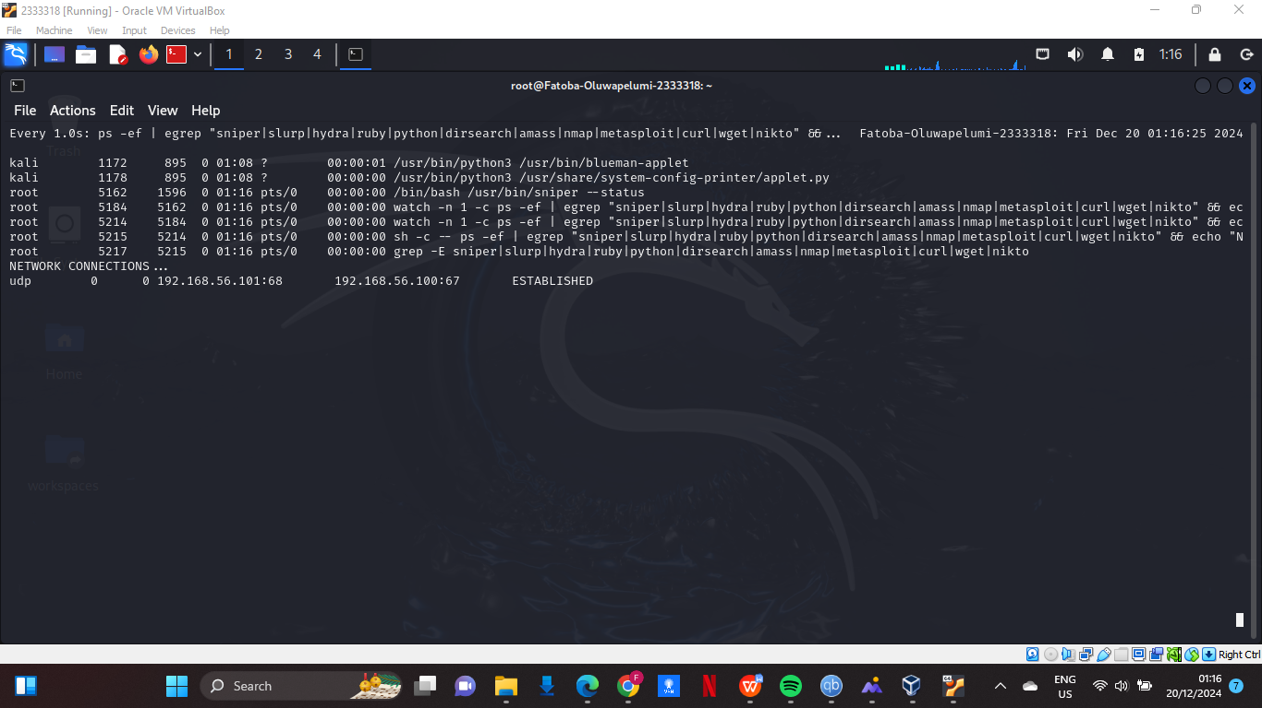

Figure 35: Using (--status)

As a feature it filters and displays results based on http return codes, it focuses on specific successful requests or errors to help identify vulnerabilities (as this can be helpful when using injectx or smuggler).

# 4.0. Successful Completions of The Two Cisco Courses

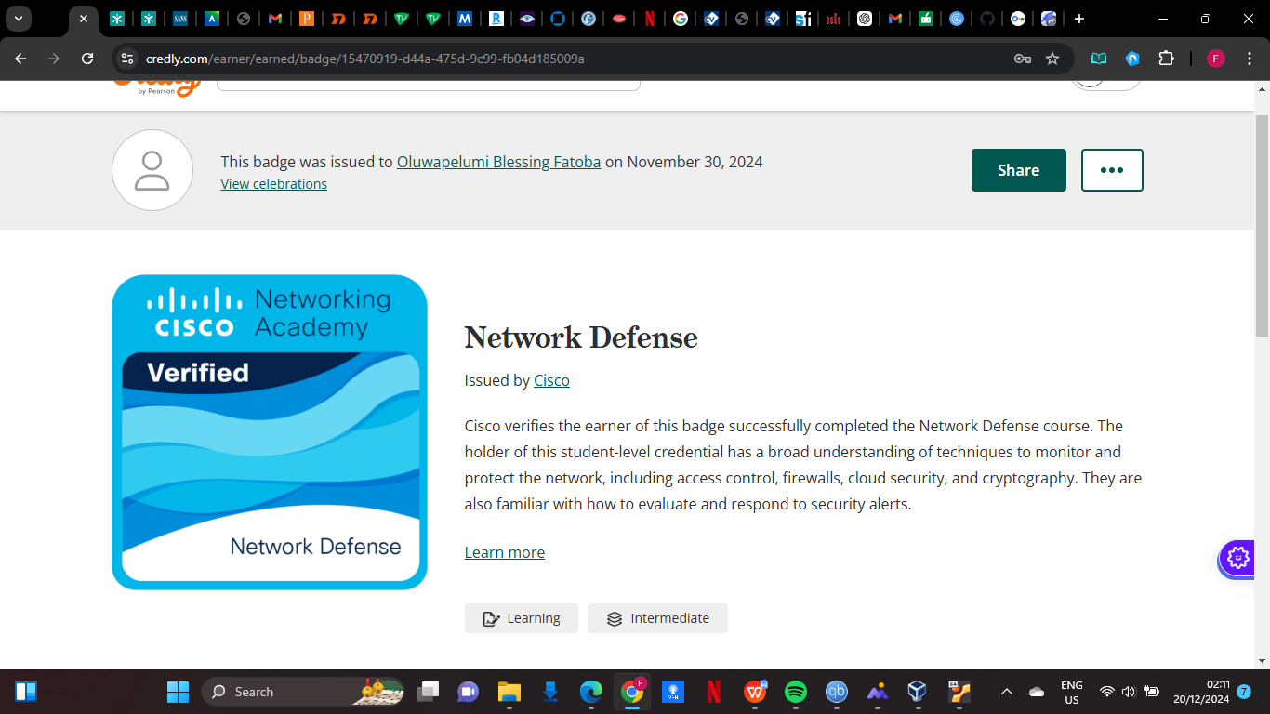

Figure 36: Network Defense

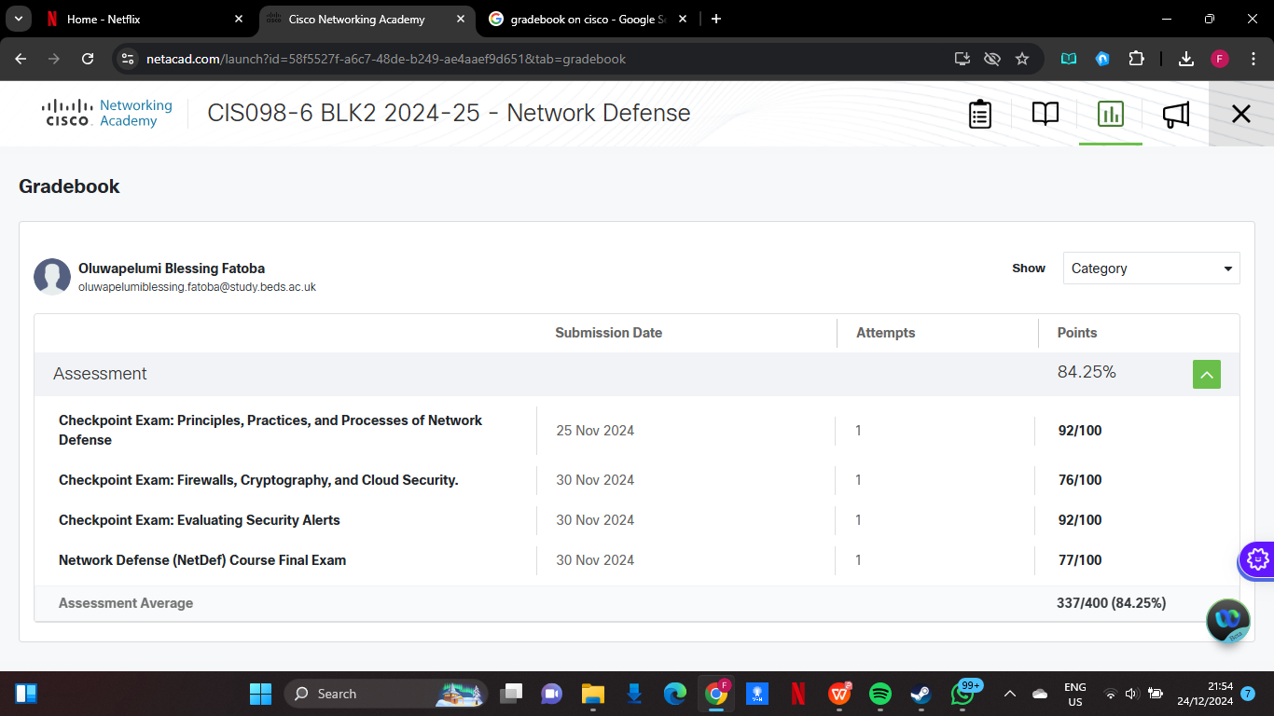

Figure 37: Gradebook Network Defense

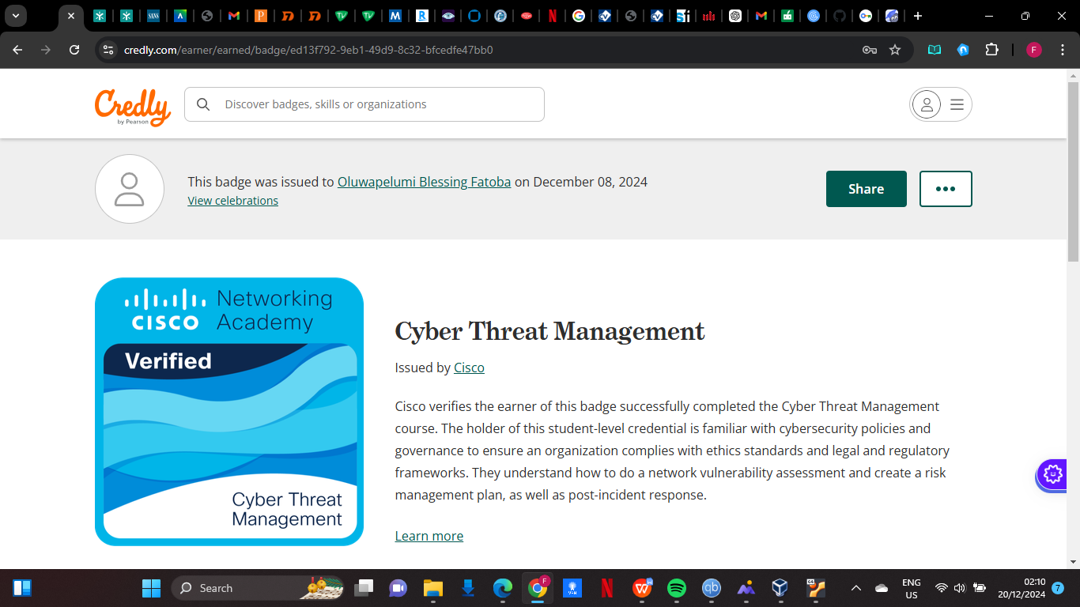

Figure 38: Cyber Threat Management

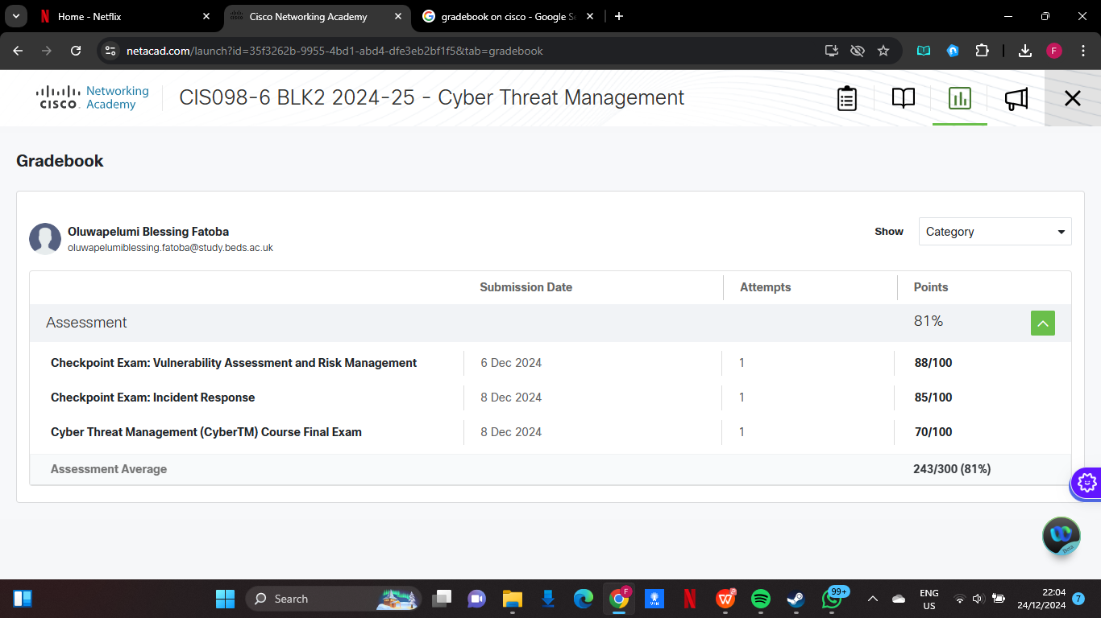

Figure 39: Gradebook Cyber Threat Management

## 4.1. Conclusion

Sniper is a great tool for practicing penetration testing and understanding actual attack routes because it offers a quick and automated way of identifying vulnerabilities in Metasploitable 2 due to metasploitable 2 vulnerable design.

## 4.2. References

Rapid 7 (2024) *Metasploitable*. Available at :https://www.rapid7.com/products/metasploit/metasploitable/ (Accessed: 20 December 2024).